**PRE PROCESSING :**

import pandas as pd

import numpy as np

from sklearn.model_selection import train_test_split

from sklearn.preprocessing import LabelEncoder, StandardScaler

# Step 1: Load the CSV data into a DataFrame

# Replace 'your_data.csv' with the path to your CSV file

data = pd.read_csv("C:\\Omega\\Semester 5\\Machine Learning\\Project\\final.csv")

# Step 2: Display basic information and statistics about the dataset

print(data.info())

print(data.describe())

# Step 3: Check for missing values

missing_values = data.isnull().sum()

print("Missing values in each column:\n", missing_values)

# Step 4: Encode categorical variables

# Label encoding for binary columns like 'Sex', 'MaritalStatus', 'AccidentArea', 'FraudFound'

label_encoders = {}

for column in ['Sex', 'MaritalStatus', 'AccidentArea', 'FraudFound', 'PoliceReportFiled', 'WitnessPresent', 'AgentType', 'BasePolicy']:

    le = LabelEncoder()

    data[column] = le.fit_transform(data[column])

    label_encoders[column] = le

# One-hot encode columns with more than 2 categories (e.g., 'Make', 'PolicyType', 'VehicleCategory')

data = pd.get_dummies(data, columns=['Make', 'PolicyType', 'VehicleCategory'], drop_first=True)

# Step 5: Handle missing values (if any)

# Filling missing values with mean for numerical columns

data.fillna(data.mean(), inplace=True)

# Step 6: Scale numerical features for better model performance

# Standardize numerical features like 'Age', 'ClaimAmount', 'VehiclePrice', etc.

scaler = StandardScaler()

numerical_cols = ['Age', 'ClaimAmount', 'VehiclePrice', 'AgeOfVehicle', 'AgeOfPolicyHolder', 'DriverRating', 'NumberOfSuppliments']

data[numerical_cols] = scaler.fit_transform(data[numerical_cols])

# Step 7: Save the preprocessed data as a single CSV file

# Assuming 'FraudFound' is the target variable

# Reorder the columns to keep the target column 'FraudFound' as the last column

data = data[[col for col in data.columns if col != 'FraudFound'] + ['FraudFound']]

# Step 8: Save the entire preprocessed dataset to a CSV file

data.to_csv('final.csv', index=False)

print("Data preprocessing complete and saved as 'final.csv'.")

**EXPLORATORY DATA ANALYSIS :**

import pandas as pd

import numpy as np

import matplotlib.pyplot as plt

import seaborn as sns

from sklearn.model_selection import train_test_split, RandomizedSearchCV

from sklearn.preprocessing import StandardScaler, LabelEncoder

from sklearn.metrics import mean_squared_error, roc_auc_score, roc_curve, accuracy_score, confusion_matrix

from sklearn.ensemble import GradientBoostingClassifier

from scipy.stats import randint

# Load the data

file_path = "C:\\Omega\\Semester 5\\Machine Learning\\Project\\final.csv"

data = pd.read_csv(file_path)

# Display basic information and initial rows of the dataset

print("Dataset Information:")

print(data.info())

print("\nFirst 5 rows of the dataset:")

print(data.head())

# Handling missing values

print("\nMissing Values:")

print(data.isnull().sum())

data.dropna(inplace=True)

# Exploratory Data Analysis (EDA)

# 1. Distribution of the target variable

sns.countplot(x='FraudFound', data=data)

plt.title('Distribution of Fraud Found')

plt.xlabel('Fraud Found (0: No, 1: Yes)')

plt.ylabel('Count')

plt.show()

# 2. Distribution of numerical features

numerical_cols = data.select_dtypes(include=[np.number]).columns

data[numerical_cols].hist(bins=15, figsize=(15, 10))

plt.suptitle('Distribution of Numerical Features')

plt.show()

# 3. Outlier Detection using box plots

num_cols = len(numerical_cols)

cols_per_row = 4

rows = (num_cols // cols_per_row) + (num_cols % cols_per_row > 0)

plt.figure(figsize=(20, 5 * rows))

for i, col in enumerate(numerical_cols):

    plt.subplot(rows, cols_per_row, i + 1)

    sns.boxplot(x=data[col])

    plt.title(f'Box Plot of {col}')

    plt.xlim(data[col].min() - 1, data[col].max() + 1)

plt.subplots_adjust(hspace=0.95, top=0.933)

plt.show()

# Prepare the data for training

X = data.drop('FraudFound', axis=1)  # Features (all columns except target)

y = data['FraudFound']  # Target variable

# Encoding categorical variables if any

le = LabelEncoder()

for col in X.select_dtypes(include=['object']).columns:

    X[col] = le.fit_transform(X[col])

# Split the data into training and testing sets

X_train, X_test, y_train, y_test = train_test_split(X, y, test_size=0.3, random_state=42)

# Standardize the numerical features (optional but recommended for some models)

scaler = StandardScaler()

X_train = scaler.fit_transform(X_train)

X_test = scaler.transform(X_test)

# Initialize and train the Gradient Boosting Classifier

gbc = GradientBoostingClassifier(random_state=42)

gbc.fit(X_train, y_train)

# Make predictions

y_pred = gbc.predict(X_test)

# Calculate accuracy

accuracy = accuracy_score(y_test, y_pred)

print(f"Accuracy: {accuracy * 100:.2f}%")

# Confusion Matrix

cm = confusion_matrix(y_test, y_pred)

print("\nConfusion Matrix:")

print(cm)

# Visualizing the Confusion Matrix

plt.figure(figsize=(6, 4))

sns.heatmap(cm, annot=True, fmt='g', cmap='Blues')

plt.title('Confusion Matrix')

plt.xlabel('Predicted Label')

plt.ylabel('True Label')

plt.show()

**GRADIENT BOOSTED NEURAL NETWORK   
FRAUD PREDICTION :**

#final 1

import pandas as pd

import numpy as np

from keras.models import Sequential

from keras.layers import Dense

from sklearn.model_selection import train_test_split

from sklearn.preprocessing import StandardScaler

from sklearn.metrics import accuracy_score, mean_squared_error

from sklearn.metrics import roc_curve, roc_auc_score, mean_absolute_error

import matplotlib.pyplot as plt

# Load the data

file_path = "C:\\Omega\\Semester 5\\Machine Learning\\Project\\final.csv"

data = pd.read_csv(file_path)

# Clean column names

data.columns = data.columns.str.strip()

# One-hot encode categorical columns

categorical_columns = data.select_dtypes(include=['object']).columns.tolist()

categorical_columns.remove('FraudFound')

if categorical_columns:

    data = pd.get_dummies(data, columns=categorical_columns, drop_first=True)

# Prepare features and target

X = data.drop(columns=['FraudFound']).values

y = data['FraudFound'].map({'Yes': 1, 'No': 0}).values

# Split the data

X_train, X_test, y_train, y_test = train_test_split(X, y, test_size=0.2, random_state=42)

# Normalize features

scaler = StandardScaler()

X_train = scaler.fit_transform(X_train)

X_test = scaler.transform(X_test)

# Define a function to create the neural network

def create_model():

    model = Sequential()

    model.add(Dense(32, activation='relu', input_dim=X_train.shape[1]))  # Input layer

    model.add(Dense(16, activation='relu'))  # Hidden layer

    model.add(Dense(1, activation='sigmoid'))  # Output layer

    model.compile(loss='binary_crossentropy', optimizer='adam', metrics=['accuracy'])

    return model

# Implementing a simple version of Gradient Boosted Neural Networks

def gradient_boosted_nn(X_train, y_train, X_test, n_estimators=5):

    n_samples = len(y_train)

    y_pred = np.zeros(n_samples)

    models = []

    # Initial model with zero predictions (base predictions)

    for _ in range(n_estimators):

        # Calculate the residuals

        residuals = y_train - y_pred

        # Create a new model for the residuals

        model = create_model()

        model.fit(X_train, residuals, epochs=10, batch_size=32, verbose=0)

        # Update predictions

        y_pred += model.predict(X_train).flatten()  # Flatten to match y_train shape

        models.append(model)

    return models, y_pred

# Train the Gradient Boosted Neural Networks

models, y_train_pred = gradient_boosted_nn(X_train, y_train, X_test)

# Make predictions on the test set

y_test_pred = np.zeros(len(y_test))

for model in models:

    y_test_pred += model.predict(X_test).flatten()

# Convert predictions to binary (using a threshold of 0.5)

y_test_pred_binary = (y_test_pred > 0.5).astype(int)

# Evaluate the model

accuracy = accuracy_score(y_test, y_test_pred_binary)

mse = mean_squared_error(y_test, y_test_pred_binary)

mae = mean_absolute_error(y_test, y_test_pred_binary)

roc_auc = roc_auc_score(y_test, y_test_pred)

# Print evaluation metrics

print(f"Gradient Boosted Neural Networks - Accuracy: {accuracy:.4f}, MSE: {mse:.4f}, MAE: {mae:.4f}, ROC AUC: {roc_auc:.4f}")

#parameter tuning

import pandas as pd

import numpy as np

from tensorflow.keras.models import Sequential

from tensorflow.keras.layers import Dense

from sklearn.model_selection import train_test_split

from sklearn.preprocessing import StandardScaler

from sklearn.metrics import accuracy_score, mean_squared_error, roc_curve, roc_auc_score, mean_absolute_error

import matplotlib.pyplot as plt

from sklearn.model_selection import RandomizedSearchCV

from tensorflow.keras.layers import Input

# Load the data

file_path = "C:\\Omega\\Semester 5\\Machine Learning\\Project\\final.csv"

data = pd.read_csv(file_path)

# Clean column names

data.columns = data.columns.str.strip()

# One-hot encode categorical columns

categorical_columns = data.select_dtypes(include=['object']).columns.tolist()

categorical_columns.remove('FraudFound')

if categorical_columns:

    data = pd.get_dummies(data, columns=categorical_columns, drop_first=True)

# Prepare features and target

X = data.drop(columns=['FraudFound']).values

y = data['FraudFound'].map({'Yes': 1, 'No': 0}).values

# Split the data

X_train, X_test, y_train, y_test = train_test_split(X, y, test_size=0.2, random_state=42)

# Normalize features

scaler = StandardScaler()

X_train = scaler.fit_transform(X_train)

X_test = scaler.transform(X_test)

# Define a function to create the neural network

def create_model(neurons_1=32, neurons_2=16):

    model = Sequential()

    model.add(Input(shape=(X_train.shape[1],)))  # Input layer using Input

    model.add(Dense(neurons_1, activation='relu'))  # Hidden layer

    model.add(Dense(neurons_2, activation='relu'))  # Hidden layer

    model.add(Dense(1, activation='sigmoid'))  # Output layer

    model.compile(loss='binary_crossentropy', optimizer='adam', metrics=['accuracy'])

    return model

# Function to perform hyperparameter tuning

def hyperparameter_tuning(X_train, y_train):

    param_dist = {

        'neurons_1': [16, 32, 64],

        'neurons_2': [8, 16, 32],

        'epochs': [10, 20],

        'batch_size': [16, 32]

    }

    best_accuracy = 0

    best_params = {}

    # Random search over specified parameter values

    for neurons_1 in param_dist['neurons_1']:

        for neurons_2 in param_dist['neurons_2']:

            for epochs in param_dist['epochs']:

                for batch_size in param_dist['batch_size']:

                    # Create and train model

                    model = create_model(neurons_1=neurons_1, neurons_2=neurons_2)

                    model.fit(X_train, y_train, epochs=epochs, batch_size=batch_size, verbose=0)

                    # Evaluate model

                    y_train_pred = model.predict(X_train).flatten()

                    y_train_pred_binary = (y_train_pred > 0.5).astype(int)

                    accuracy = accuracy_score(y_train, y_train_pred_binary)

                    # Check if this is the best model

                    if accuracy > best_accuracy:

                        best_accuracy = accuracy

                        best_params = {

                            'neurons_1': neurons_1,

                            'neurons_2': neurons_2,

                            'epochs': epochs,

                            'batch_size': batch_size

                        }

    return best_params

# Perform hyperparameter tuning

best_params = hyperparameter_tuning(X_train, y_train)

print("Best Parameters: ", best_params)

# Train the model with the best parameters

best_model = create_model(neurons_1=best_params['neurons_1'],

                           neurons_2=best_params['neurons_2'])

best_model.fit(X_train, y_train, epochs=best_params['epochs'], batch_size=best_params['batch_size'], verbose=1)

# Make predictions on the test set

y_test_pred = best_model.predict(X_test).flatten()

# Convert predictions to binary (using a threshold of 0.5)

y_test_pred_binary = (y_test_pred > 0.5).astype(int)

# Evaluate the model

accuracy = accuracy_score(y_test, y_test_pred_binary)

mse = mean_squared_error(y_test, y_test_pred_binary)

mae = mean_absolute_error(y_test, y_test_pred_binary)

roc_auc = roc_auc_score(y_test, y_test_pred)

# Print evaluation metrics

print(f"Final Model with Best Parameters - Accuracy: {accuracy:.4f}, MSE: {mse:.4f}, MAE: {mae:.4f}, ROC AUC: {roc_auc:.4f}")

# Plot ROC Curve

fpr, tpr, thresholds = roc_curve(y_test, y_test_pred)

plt.figure(figsize=(8, 6))

plt.plot(fpr, tpr, label='ROC Curve (area = {:.2f})'.format(roc_auc))

plt.plot([0, 1], [0, 1], 'k--')  # Diagonal line

plt.xlim([0.0, 1.0])

plt.ylim([0.0, 1.05])

plt.xlabel('False Positive Rate')

plt.ylabel('True Positive Rate')

plt.title('Receiver Operating Characteristic (ROC) Curve')

plt.legend(loc='lower right')

plt.grid()

plt.show()

import pandas as pd

import numpy as np

from tensorflow.keras.models import Sequential

from tensorflow.keras.layers import Dense

from sklearn.model_selection import train_test_split

from sklearn.preprocessing import StandardScaler

from sklearn.metrics import accuracy_score, mean_squared_error, roc_curve, roc_auc_score, mean_absolute_error

import matplotlib.pyplot as plt

from sklearn.model_selection import RandomizedSearchCV

from tensorflow.keras.layers import Input

from tensorflow.keras.layers import Dropout

from tensorflow.keras.callbacks import EarlyStopping

from sklearn.model_selection import KFold

# Load the data

file_path = "C:\\Omega\\Semester 5\\Machine Learning\\Project\\final.csv"

data = pd.read_csv(file_path)

# Clean column names

data.columns = data.columns.str.strip()

# One-hot encode categorical columns

categorical_columns = data.select_dtypes(include=['object']).columns.tolist()

categorical_columns.remove('FraudFound')

if categorical_columns:

    data = pd.get_dummies(data, columns=categorical_columns, drop_first=True)

# Prepare features and target

X = data.drop(columns=['FraudFound']).values

y = data['FraudFound'].map({'Yes': 1, 'No': 0}).values

# Split the data

X_train, X_test, y_train, y_test = train_test_split(X, y, test_size=0.2, random_state=42)

# Normalize features

scaler = StandardScaler()

X_train = scaler.fit_transform(X_train)

X_test = scaler.transform(X_test)

# Define a function to create the neural network with Dropout layers

def create_model(neurons_1=32, neurons_2=16, dropout_rate=0.2):

    model = Sequential()

    model.add(Input(shape=(X_train.shape[1],)))  # Input layer

    model.add(Dense(neurons_1, activation='relu'))  # Hidden layer

    model.add(Dropout(dropout_rate))  # Dropout layer to prevent overfitting

    model.add(Dense(neurons_2, activation='relu'))  # Hidden layer

    model.add(Dropout(dropout_rate))  # Dropout layer to prevent overfitting

    model.add(Dense(1, activation='sigmoid'))  # Output layer

    model.compile(loss='binary_crossentropy', optimizer='adam', metrics=['accuracy'])

    return model

# Implement k-fold cross-validation to prevent overfitting

def k_fold_validation(X, y, n_splits=5):

    kfold = KFold(n_splits=n_splits, shuffle=True, random_state=42)

    fold_no = 1

    results = []

    for train_idx, val_idx in kfold.split(X):

        X_train_fold, X_val_fold = X[train_idx], X[val_idx]

        y_train_fold, y_val_fold = y[train_idx], y[val_idx]

        # Create the model

        model = create_model(neurons_1=best_params['neurons_1'],

                             neurons_2=best_params['neurons_2'])

        # Early stopping to avoid overfitting

        early_stopping = EarlyStopping(monitor='val_loss', patience=3, restore_best_weights=True)

        # Train the model

        model.fit(X_train_fold, y_train_fold, epochs=best_params['epochs'], batch_size=best_params['batch_size'],

                  validation_data=(X_val_fold, y_val_fold), callbacks=[early_stopping], verbose=1)

        # Evaluate the model on the validation set

        y_val_pred = model.predict(X_val_fold).flatten()

        y_val_pred_binary = (y_val_pred > 0.5).astype(int)

        accuracy = accuracy_score(y_val_fold, y_val_pred_binary)

        results.append(accuracy)

        print(f"Fold {fold_no} - Accuracy: {accuracy:.4f}")

        fold_no += 1

    avg_accuracy = np.mean(results)

    print(f"Average accuracy after k-fold cross-validation: {avg_accuracy:.4f}")

    return avg_accuracy

# Perform k-fold cross-validation to evaluate model performance

avg_accuracy = k_fold_validation(X_train, y_train)

# Train the model with the best parameters and early stopping on the entire training set

best_model = create_model(neurons_1=best_params['neurons_1'],

                          neurons_2=best_params['neurons_2'])

early_stopping = EarlyStopping(monitor='val_loss', patience=3, restore_best_weights=True)

best_model.fit(X_train, y_train, epochs=best_params['epochs'], batch_size=best_params['batch_size'],

               validation_split=0.2, callbacks=[early_stopping], verbose=1)

# Make predictions on the test set

y_test_pred = best_model.predict(X_test).flatten()

# Convert predictions to binary (using a threshold of 0.5)

y_test_pred_binary = (y_test_pred > 0.5).astype(int)

# Evaluate the model

accuracy = accuracy_score(y_test, y_test_pred_binary)

mse = mean_squared_error(y_test, y_test_pred_binary)

mae = mean_absolute_error(y_test, y_test_pred_binary)

roc_auc = roc_auc_score(y_test, y_test_pred)

# Print evaluation metrics

print(f"Final Model with Best Parameters - Accuracy: {accuracy:.4f}, MSE: {mse:.4f}, MAE: {mae:.4f}, ROC AUC: {roc_auc:.4f}")

# Plot ROC Curve

fpr, tpr, thresholds = roc_curve(y_test, y_test_pred)

plt.figure(figsize=(8, 6))

plt.plot(fpr, tpr, label='ROC Curve (area = {:.2f})'.format(roc_auc))

plt.plot([0, 1], [0, 1], 'k--')  # Diagonal line

plt.xlim([0.0, 1.0])

plt.ylim([0.0, 1.05])

plt.xlabel('False Positive Rate')

plt.ylabel('True Positive Rate')

plt.title('Receiver Operating Characteristic (ROC) Curve')

plt.legend(loc='lower right')

plt.grid()

plt.show()

**Policy type prediction :**

import pandas as pd

import numpy as np

from tensorflow.keras.models import Sequential

from tensorflow.keras.layers import Dense, Dropout, Input

from sklearn.model_selection import train_test_split, KFold

from sklearn.preprocessing import StandardScaler, LabelEncoder

from sklearn.metrics import accuracy_score, mean_squared_error, roc_curve, roc_auc_score, mean_absolute_error

import matplotlib.pyplot as plt

from tensorflow.keras.callbacks import EarlyStopping

# Load the data

file_path = "C:\\Omega\\Semester 5\\Machine Learning\\Project\\final.csv"

data = pd.read_csv(file_path)

# Clean column names

data.columns = data.columns.str.strip()

# Encode the target variable (PolicyType)

label_encoder = LabelEncoder()

data['PolicyType'] = label_encoder.fit_transform(data['PolicyType'])

# One-hot encode categorical columns

categorical_columns = data.select_dtypes(include=['object']).columns.tolist()

if categorical_columns:

    data = pd.get_dummies(data, columns=categorical_columns, drop_first=True)

# Prepare features and target

X = data.drop(columns=['PolicyType']).values

y = data['PolicyType'].values

# Split the data into training and test sets

X_train, X_test, y_train, y_test = train_test_split(X, y, test_size=0.2, random_state=42)

# Normalize the features

scaler = StandardScaler()

X_train = scaler.fit_transform(X_train)

X_test = scaler.transform(X_test)

# Define a function to create the neural network model with Dropout layers

def create_model(neurons_1=32, neurons_2=16, dropout_rate=0.2):

    model = Sequential()

    model.add(Input(shape=(X_train.shape[1],)))  # Input layer

    model.add(Dense(neurons_1, activation='relu'))  # Hidden layer 1

    model.add(Dropout(dropout_rate))  # Dropout layer to prevent overfitting

    model.add(Dense(neurons_2, activation='relu'))  # Hidden layer 2

    model.add(Dropout(dropout_rate))  # Dropout layer

    model.add(Dense(len(np.unique(y)), activation='softmax'))  # Output layer for multi-class classification

    model.compile(loss='sparse_categorical_crossentropy', optimizer='adam', metrics=['accuracy'])

    return model

# Implement k-fold cross-validation to prevent overfitting

def k_fold_validation(X, y, n_splits=5):

    kfold = KFold(n_splits=n_splits, shuffle=True, random_state=42)

    fold_no = 1

    results = []

    for train_idx, val_idx in kfold.split(X):

        X_train_fold, X_val_fold = X[train_idx], X[val_idx]

        y_train_fold, y_val_fold = y[train_idx], y[val_idx]

        # Create the model

        model = create_model(neurons_1=32, neurons_2=16, dropout_rate=0.3)

        # Early stopping to avoid overfitting

        early_stopping = EarlyStopping(monitor='val_loss', patience=3, restore_best_weights=True)

        # Train the model

        model.fit(X_train_fold, y_train_fold, epochs=50, batch_size=32,

                  validation_data=(X_val_fold, y_val_fold), callbacks=[early_stopping], verbose=1)

        # Evaluate the model on the validation set

        y_val_pred = np.argmax(model.predict(X_val_fold), axis=1)

        accuracy = accuracy_score(y_val_fold, y_val_pred)

        results.append(accuracy)

        print(f"Fold {fold_no} - Accuracy: {accuracy:.4f}")

        fold_no += 1

    avg_accuracy = np.mean(results)

    print(f"Average accuracy after k-fold cross-validation: {avg_accuracy:.4f}")

    return avg_accuracy

# Perform k-fold cross-validation to evaluate model performance

avg_accuracy = k_fold_validation(X_train, y_train)

# Create and train the final model using the best parameters

best_model = create_model(neurons_1=32, neurons_2=16, dropout_rate=0.3)

early_stopping = EarlyStopping(monitor='val_loss', patience=3, restore_best_weights=True)

# Train on the entire training set with validation split

best_model.fit(X_train, y_train, epochs=50, batch_size=32, validation_split=0.2, callbacks=[early_stopping], verbose=1)

# Make predictions on the test set

y_test_pred = np.argmax(best_model.predict(X_test), axis=1)

# Evaluate the final model

accuracy = accuracy_score(y_test, y_test_pred)

mse = mean_squared_error(y_test, y_test_pred)

mae = mean_absolute_error(y_test, y_test_pred)

roc_auc = roc_auc_score(y_test, best_model.predict(X_test), multi_class="ovr")

# Print evaluation metrics

print(f"Final Model with Best Parameters - Accuracy: {accuracy:.4f}, MSE: {mse:.4f}, MAE: {mae:.4f}, ROC AUC: {roc_auc:.4f}")

# Plot ROC Curve

y_test_pred_prob = best_model.predict(X_test)

fpr = {}

tpr = {}

for i in range(len(np.unique(y))):

    fpr[i], tpr[i], _ = roc_curve(y_test, y_test_pred_prob[:, i], pos_label=i)

plt.figure(figsize=(8, 6))

for i in range(len(np.unique(y))):

    plt.plot(fpr[i], tpr[i], label=f'Class {i} ROC Curve')

plt.plot([0, 1], [0, 1], 'k--')  # Diagonal line

plt.xlim([0.0, 1.0])

plt.ylim([0.0, 1.05])

plt.xlabel('False Positive Rate')

plt.ylabel('True Positive Rate')

plt.title('Receiver Operating Characteristic (ROC) Curve')

plt.legend(loc='lower right')

plt.grid()

plt.show()

**FEED FORWARD NEURAL NETWORKS**

**Fraud detection :**

import pandas as pd

import numpy as np

import tensorflow as tf

from tensorflow.keras.models import Sequential

from tensorflow.keras.layers import Dense

from tensorflow.keras.optimizers import Adam

from sklearn.model_selection import train_test_split

from sklearn.preprocessing import StandardScaler

from sklearn.metrics import mean_squared_error, mean_absolute_error, roc_auc_score

# Load the data

file_path = "C:\\Omega\\Semester 5\\Machine Learning\\Project\\final.csv"

data = pd.read_csv(file_path)

# Clean column names

data.columns = data.columns.str.strip()

# One-hot encode categorical columns

categorical_columns = data.select_dtypes(include=['object']).columns.tolist()

categorical_columns.remove('FraudFound')

if categorical_columns:

    data = pd.get_dummies(data, columns=categorical_columns, drop_first=True)

# Prepare features and target

X = data.drop(columns=['FraudFound']).values

y = data['FraudFound'].map({'Yes': 1, 'No': 0}).values

# Split the data

X_train, X_test, y_train, y_test = train_test_split(X, y, test_size=0.2, random_state=42)

# Normalize features

scaler = StandardScaler()

X_train = scaler.fit_transform(X_train)

X_test = scaler.transform(X_test)

# Define a function to create the neural network

def create_model():

    model = Sequential()

    model.add(Dense(32, activation='relu', input_dim=X_train.shape[1]))  # Input layer

    model.add(Dense(16, activation='relu'))  # Hidden layer

    model.add(Dense(1, activation='sigmoid'))  # Output layer

    model.compile(loss='binary_crossentropy', optimizer='adam', metrics=['accuracy'])

    return model

# Create and train the model

model = create_model()

model.fit(X_train, y_train, epochs=10, batch_size=32, validation_split=0.2, verbose=1)

# Evaluate the model

test_loss, test_acc = model.evaluate(X_test, y_test)

print(f'\nTest accuracy: {test_acc:.4f}')

# Make predictions on the test set

y_test_pred = model.predict(X_test)

y_test_pred_classes = (y_test_pred > 0.5).astype(int).flatten()

# Calculate additional metrics

mse = mean_squared_error(y_test, y_test_pred_classes)

mae = mean_absolute_error(y_test, y_test_pred_classes)

rmse = np.sqrt(mse)

roc_auc = roc_auc_score(y_test, y_test_pred)

# Print the metrics

print(f'Accuracy: {test_acc:.4f}')

print(f'MSE: {mse:.4f}')

print(f'RMSE: {rmse:.4f}')

print(f'MAE: {mae:.4f}')

print(f'ROC AUC: {roc_auc:.4f}')

#parameter tuning

import pandas as pd

import numpy as np

import tensorflow as tf

from tensorflow.keras.models import Sequential

from tensorflow.keras.layers import Dense

from sklearn.model_selection import train_test_split

from sklearn.preprocessing import StandardScaler

from sklearn.metrics import mean_squared_error, mean_absolute_error, roc_auc_score

import keras_tuner as kt

# Load the data

file_path = "C:\\Omega\\Semester 5\\Machine Learning\\Project\\final.csv"

data = pd.read_csv(file_path)

# Clean column names

data.columns = data.columns.str.strip()

# One-hot encode categorical columns

categorical_columns = data.select_dtypes(include=['object']).columns.tolist()

categorical_columns.remove('FraudFound')

if categorical_columns:

    data = pd.get_dummies(data, columns=categorical_columns, drop_first=True)

# Prepare features and target

X = data.drop(columns=['FraudFound']).values

y = data['FraudFound'].map({'Yes': 1, 'No': 0}).values

# Split the data

X_train, X_test, y_train, y_test = train_test_split(X, y, test_size=0.2, random_state=42)

# Normalize features

scaler = StandardScaler()

X_train = scaler.fit_transform(X_train)

X_test = scaler.transform(X_test)

# Define the model building function with hyperparameters

def build_model(hp):

    model = Sequential()

    # Choose number of hidden layers

    num_hidden_layers = hp.Int('num_hidden_layers', min_value=1, max_value=3)

    # Add input layer

    model.add(Dense(units=hp.Int('neurons_input_layer', min_value=16, max_value=64, step=16),

                    activation=hp.Choice('activation_input_layer', values=['relu', 'tanh']),

                    input_dim=X_train.shape[1]))

    # Add hidden layers

    for _ in range(num_hidden_layers - 1):

        model.add(Dense(units=hp.Int('neurons_hidden_layer', min_value=16, max_value=64, step=16),

                        activation=hp.Choice('activation_hidden_layer', values=['relu', 'tanh'])))

    # Add output layer

    model.add(Dense(1, activation='sigmoid'))  # Output layer

    model.compile(loss='binary_crossentropy', optimizer='adam', metrics=['accuracy'])

    return model

# Set up the tuner

tuner = kt.tuners.RandomSearch(

    build_model,

    objective='val_accuracy',

    max_trials=10,

    executions_per_trial=3,

    directory='my_dir',

    project_name='fraud_detection'

)

# Perform the hyperparameter search

tuner.search(X_train, y_train, epochs=10, batch_size=32, validation_split=0.2)

# Get the best model

best_model = tuner.get_best_models(num_models=1)[0]

# Evaluate the best model on the test set

test_loss, test_acc = best_model.evaluate(X_test, y_test)

print(f'\nBest Test accuracy: {test_acc:.4f}')

# Make predictions on the test set

y_test_pred = best_model.predict(X_test)

y_test_pred_classes = (y_test_pred > 0.5).astype(int).flatten()

# Calculate additional metrics

mse = mean_squared_error(y_test, y_test_pred_classes)

mae = mean_absolute_error(y_test, y_test_pred_classes)

rmse = np.sqrt(mse)

roc_auc = roc_auc_score(y_test, y_test_pred)

# Print the metrics

print(f'Best Accuracy: {test_acc:.4f}')

print(f'MSE: {mse:.4f}')

print(f'RMSE: {rmse:.4f}')

print(f'MAE: {mae:.4f}')

print(f'ROC AUC: {roc_auc:.4f}')

**Policy type prediction :**

import numpy as np

from tensorflow.keras.models import Sequential

from tensorflow.keras.layers import Dense

from sklearn.metrics import accuracy_score, mean_squared_error, mean_absolute_error, roc_auc_score

from sklearn.preprocessing import StandardScaler, LabelEncoder

from sklearn.model_selection import train_test_split

import pandas as pd

# Load the data

file_path = "C:\\Omega\\Semester 5\\Machine Learning\\Project\\final.csv"

data = pd.read_csv(file_path)

# Clean column names

data.columns = data.columns.str.strip()

# Encode the target variable (PolicyType) using LabelEncoder

label_encoder = LabelEncoder()

data['PolicyType'] = label_encoder.fit_transform(data['PolicyType'])

# One-hot encode categorical features

categorical_columns = data.select_dtypes(include=['object']).columns.tolist()

if categorical_columns:

    data = pd.get_dummies(data, columns=categorical_columns, drop_first=True)

# Separate features and target variable

X = data.drop(columns=['PolicyType']).values

y = data['PolicyType'].values

# Split the data into train and test sets

X_train, X_test, y_train, y_test = train_test_split(X, y, test_size=0.2, random_state=42)

# Standardize the features

scaler = StandardScaler()

X_train = scaler.fit_transform(X_train)

X_test = scaler.transform(X_test)

# One-hot encode the target variable (y_train and y_test) for multiclass classification

y_train_onehot = pd.get_dummies(y_train).values

y_test_onehot = pd.get_dummies(y_test).values

# Define a function to create the neural network for multiclass classification

def create_feedforward_nn():

    model = Sequential()

    model.add(Dense(32, activation='relu', input_dim=X_train.shape[1]))  # Input layer

    model.add(Dense(16, activation='relu'))  # Hidden layer

    model.add(Dense(y_train_onehot.shape[1], activation='softmax'))  # Output layer for multiclass classification

    model.compile(loss='categorical_crossentropy', optimizer='adam', metrics=['accuracy'])

    return model

# Create and train the feedforward neural network

model = create_feedforward_nn()

model.fit(X_train, y_train_onehot, epochs=10, batch_size=32, verbose=0)  # Train for 50 epochs

# Make predictions on the test set

y_test_pred_proba = model.predict(X_test)

# Convert predicted probabilities to class labels

y_test_pred = np.argmax(y_test_pred_proba, axis=1)

# Evaluate the model using accuracy, MSE, MAE, and ROC AUC

accuracy = accuracy_score(y_test, y_test_pred)

mse = mean_squared_error(y_test, y_test_pred)

mae = mean_absolute_error(y_test, y_test_pred)

roc_auc = roc_auc_score(y_test_onehot, y_test_pred_proba, multi_class='ovr')

# Print evaluation metrics

print(f"Feedforward Neural Networks - Accuracy for Policy Type: {accuracy:.4f}")

print(f"MSE: {mse:.4f}, MAE: {mae:.4f}, ROC AUC: {roc_auc:.4f}")

#parametertuning

import numpy as np

import pandas as pd

from keras.models import Sequential

from keras.layers import Dense, Dropout, Input

from scikeras.wrappers import KerasClassifier

from sklearn.model_selection import RandomizedSearchCV, train_test_split

from sklearn.preprocessing import StandardScaler, LabelEncoder

from sklearn.metrics import accuracy_score, mean_squared_error, mean_absolute_error, roc_auc_score, roc_curve

from keras.callbacks import EarlyStopping

import matplotlib.pyplot as plt

# Load the data

file_path = "C:\\Omega\\Semester 5\\Machine Learning\\Project\\final.csv"

data = pd.read_csv(file_path)

# Clean column names

data.columns = data.columns.str.strip()

# Encode the target variable (PolicyType)

label_encoder = LabelEncoder()

data['PolicyType'] = label_encoder.fit_transform(data['PolicyType'])

# One-hot encode categorical columns

categorical_columns = data.select_dtypes(include=['object']).columns.tolist()

if categorical_columns:

    data = pd.get_dummies(data, columns=categorical_columns, drop_first=True)

# Prepare features and target

X = data.drop(columns=['PolicyType']).values

y = data['PolicyType'].values

# Split the data into training and test sets

X_train, X_test, y_train, y_test = train_test_split(X, y, test_size=0.2, random_state=42)

# Normalize the features

scaler = StandardScaler()

X_train = scaler.fit_transform(X_train)

X_test = scaler.transform(X_test)

# Function to create model (with hyperparameters for tuning)

def create_model(neurons_1=32, neurons_2=16, dropout_rate=0.2, optimizer='adam'):

    model = Sequential()

    model.add(Input(shape=(X_train.shape[1],)))  # Input layer

    model.add(Dense(neurons_1, activation='relu'))  # First hidden layer

    model.add(Dropout(dropout_rate))  # Dropout layer

    model.add(Dense(neurons_2, activation='relu'))  # Second hidden layer

    model.add(Dropout(dropout_rate))  # Dropout layer

    model.add(Dense(len(np.unique(y)), activation='softmax'))  # Output layer

    model.compile(loss='sparse_categorical_crossentropy', optimizer=optimizer, metrics=['accuracy'])

    return model

# Wrap the model using KerasClassifier for scikit-learn compatibility

model = KerasClassifier(model=create_model, verbose=0)

# Define the hyperparameters to tune (note the prefix model__)

param_grid = {

    'model__neurons_1': [32, 64, 128],

    'model__neurons_2': [16, 32, 64],

    'model__dropout_rate': [0.2, 0.3, 0.4],

    'batch_size': [32, 64, 128],

    'epochs': [10, 20, 30],

    'optimizer': ['adam', 'rmsprop']

}

# Use RandomizedSearchCV for hyperparameter tuning

random_search = RandomizedSearchCV(estimator=model, param_distributions=param_grid, n_iter=10, cv=3, n_jobs=-1, random_state=42)

random_search_result = random_search.fit(X_train, y_train)

# Get the best hyperparameters from the RandomizedSearchCV

print(f"Best Hyperparameters: {random_search_result.best_params_}")

# Get the best model

best_model = random_search_result.best_estimator_

# Early stopping callback to avoid overfitting during training

early_stopping = EarlyStopping(monitor='val_loss', patience=3, restore_best_weights=True)

# Train the model with the best hyperparameters

best_model.fit(X_train, y_train, validation_split=0.2, epochs=random_search_result.best_params_['epochs'],

               batch_size=random_search_result.best_params_['batch_size'], callbacks=[early_stopping], verbose=1)

# Make predictions on the test set

y_test_pred = best_model.predict(X_test)

if len(y_test_pred.shape) == 1:  # If predictions are 1D, treat them as class labels

    y_test_pred = y_test_pred

else:  # Otherwise, get the class with the highest probability

    y_test_pred = np.argmax(y_test_pred, axis=1)

# Calculate evaluation metrics

accuracy = accuracy_score(y_test, y_test_pred)

mse = mean_squared_error(y_test, y_test_pred)

mae = mean_absolute_error(y_test, y_test_pred)

roc_auc = roc_auc_score(y_test, best_model.predict_proba(X_test), multi_class="ovr")

# Print evaluation metrics

print(f"Final Model - Accuracy: {accuracy:.4f}")

print(f"MSE: {mse:.4f}")

print(f"MAE: {mae:.4f}")

print(f"ROC AUC: {roc_auc:.4f}")

# Plot ROC Curve for each class

y_test_pred_prob = best_model.predict_proba(X_test)

fpr = {}

tpr = {}

# Plot ROC curve for each class

plt.figure(figsize=(8, 6))

for i in range(len(np.unique(y))):

    fpr[i], tpr[i], _ = roc_curve(y_test, y_test_pred_prob[:, i], pos_label=i)

    plt.plot(fpr[i], tpr[i], label=f'Class {i} ROC Curve')

plt.plot([0, 1], [0, 1], 'k--')  # Diagonal line

plt.xlim([0.0, 1.0])

plt.ylim([0.0, 1.05])

plt.xlabel('False Positive Rate')

plt.ylabel('True Positive Rate')

plt.title('Receiver Operating Characteristic (ROC) Curve')

plt.legend(loc='lower right')

plt.grid()

plt.show()

**LSTM**

**Fraud detection ;**

import pandas as pd

import numpy as np

from sklearn.model_selection import train_test_split

from sklearn.preprocessing import StandardScaler, LabelEncoder

from sklearn.linear_model import LogisticRegression

from sklearn.feature_selection import RFE

from sklearn.metrics import mean_squared_error, roc_auc_score, accuracy_score

from tensorflow.keras.models import Sequential, load_model

from tensorflow.keras.layers import LSTM, Dense, Dropout

from keras_tuner import RandomSearch

from tensorflow.keras.optimizers import Adam

from math import sqrt

import matplotlib.pyplot as plt

import plotly.graph_objs as go

import plotly.io as pio

# Load your dataset (adjust the path if needed)

file_path = "/Users/i.seviantojensima/Desktop/Sem 5/Machine Learning/ml project/final.csv"

data = pd.read_csv(file_path)

# Sample a smaller dataset for faster testing

data_sample = data.sample(n=1000, random_state=42)  # Adjust n as needed

# Separate features and target variable

X = data_sample.drop(columns=['FraudFound'])  # Replace 'FraudFound' with your target column name if different

y = data_sample['FraudFound'].apply(lambda x: 1 if x == 'Yes' else 0)  # Convert to binary

# Encode categorical features using LabelEncoder

X_encoded = X.copy()

label_encoders = {}

for column in X.select_dtypes(include=['object']).columns:

    le = LabelEncoder()

    X_encoded[column] = le.fit_transform(X[column])

    label_encoders[column] = le

# Standardize the features

scaler = StandardScaler()

X_scaled = scaler.fit_transform(X_encoded)

# Split the data into training and testing sets for RFE

X_train, X_test, y_train, y_test = train_test_split(X_scaled, y, test_size=0.2, random_state=42)

# Initialize a simpler model for RFE

model = LogisticRegression(max_iter=1000)  # Ensure enough iterations

# Initialize RFE with the LogisticRegression as the estimator

n_features_to_select = 5

rfe = RFE(estimator=model, n_features_to_select=n_features_to_select)

# Fit RFE

rfe.fit(X_train, y_train)

# Get the selected features

selected_features = X_encoded.columns[rfe.support_]

print("Selected Features:")

print(selected_features)

# Visualize feature ranking

ranking = pd.DataFrame({'Feature': X_encoded.columns, 'Ranking': rfe.ranking_})

print("\nFeature Ranking:")

print(ranking.sort_values(by='Ranking'))

plt.figure(figsize=(12, 6))

plt.barh(ranking['Feature'], ranking['Ranking'], color='skyblue')

plt.xlabel('Ranking')

plt.title('Feature Ranking using RFE')

plt.gca().invert_yaxis()

plt.show()

# Use the selected features for LSTM model training

X_train_rfe = X_train[:, rfe.support_]

X_test_rfe = X_test[:, rfe.support_]

# Reshape data for LSTM [samples, time steps, features]

X_train_reshaped = X_train_rfe.reshape((X_train_rfe.shape[0], 1, X_train_rfe.shape[1]))

X_test_reshaped = X_test_rfe.reshape((X_test_rfe.shape[0], 1, X_test_rfe.shape[1]))

# Define the model-building function for Keras Tuner

def build_model(hp):

    model = Sequential()

    model.add(LSTM(

        units=hp.Int('units', min_value=32, max_value=128, step=16),

        input_shape=(X_train_reshaped.shape[1], X_train_reshaped.shape[2]),

        return_sequences=True

    ))

    model.add(Dropout(hp.Float('dropout', min_value=0.2, max_value=0.5, step=0.1)))

    model.add(LSTM(

        units=hp.Int('units_2', min_value=32, max_value=128, step=16),

        return_sequences=False

    ))

    model.add(Dropout(hp.Float('dropout_2', min_value=0.2, max_value=0.5, step=0.1)))

    model.add(Dense(1, activation='sigmoid'))

    model.compile(

        optimizer=Adam(learning_rate=hp.Float('learning_rate', min_value=1e-4, max_value=1e-2, sampling='log')),

        loss='binary_crossentropy',

        metrics=['accuracy']

    )

    return model

# Set up the Keras Tuner Random Search

tuner = RandomSearch(

    build_model,

    objective='val_accuracy',

    max_trials=10,

    executions_per_trial=1,

    directory='tuner_results',

    project_name='lstm_fraud_detection'

)

# Perform the search for the best hyperparameters

tuner.search(X_train_reshaped, y_train, epochs=10, batch_size=32, validation_split=0.2)

# Get the optimal hyperparameters

best_hps = tuner.get_best_hyperparameters(num_trials=1)[0]

# Print the best hyperparameters found

print(f"The optimal number of units in the first LSTM layer is {best_hps.get('units')}")

print(f"The optimal number of units in the second LSTM layer is {best_hps.get('units_2')}")

print(f"The optimal dropout rate for the first LSTM layer is {best_hps.get('dropout')}")

print(f"The optimal dropout rate for the second LSTM layer is {best_hps.get('dropout_2')}")

print(f"The optimal learning rate is {best_hps.get('learning_rate')}")

# Build the model with the best hyperparameters and train it

model = tuner.hypermodel.build(best_hps)

history = model.fit(X_train_reshaped, y_train, epochs=20, batch_size=32, validation_split=0.2)

# Save the trained model

model.save('lstm_fraud_model.h5')

# Load the model

model = load_model('lstm_fraud_model.h5')

# Model evaluation

y_pred_prob = model.predict(X_test_reshaped)

mse = mean_squared_error(y_test, y_pred_prob)

rmse = sqrt(mse)

auc = roc_auc_score(y_test, y_pred_prob)

y_pred = (y_pred_prob > 0.5).astype(int)

accuracy = accuracy_score(y_test, y_pred)

# Display results

print(f"MSE: {mse:.4f}")

print(f"RMSE: {rmse:.4f}")

print(f"AUC-ROC: {auc:.4f}")

print(f"Accuracy: {accuracy:.4f}")

**Policy type prediction :**

import numpy as np

import pandas as pd

from sklearn.preprocessing import LabelEncoder

from sklearn.model_selection import train_test_split

from sklearn.metrics import accuracy_score, mean_squared_error, roc_auc_score

from keras.models import Sequential # type: ignore

from keras.layers import LSTM, Dense, Dropout # type: ignore

import keras_tuner as kt

from keras.callbacks import EarlyStopping # type: ignore

# Load the dataset

data = pd.read_csv('/Users/i.seviantojensima/Desktop/Sem 5/Machine Learning/ml project/final.csv')

# Preprocessing

data.ffill(inplace=True)  # Fill missing values

# Assuming 'PolicyType' is the target variable

X = data.drop('PolicyType', axis=1)  # Features

y = data['PolicyType']  # Target variable

# Encode categorical features

X = pd.get_dummies(X)

label_encoder = LabelEncoder()

y = label_encoder.fit_transform(y)

# Scale numerical features

X = (X - X.mean()) / X.std()  # Standardization

# Reshape X to 3D array: (samples, timesteps, features)

X = X.values.reshape(X.shape[0], 1, X.shape[1])  # Add time step of 1

# Train-test split

X_train, X_test, y_train, y_test = train_test_split(X, y, test_size=0.2, random_state=42)

# Optional: Use a smaller subset of training data during tuning to speed up the process

X_train_tune, _, y_train_tune, _ = train_test_split(X_train, y_train, test_size=0.8, random_state=42)

# Build a baseline model (before hyperparameter tuning)

baseline_model = Sequential()

baseline_model.add(LSTM(units=64, return_sequences=True, input_shape=(X_train.shape[1], X_train.shape[2])))

baseline_model.add(Dropout(0.2))

baseline_model.add(LSTM(units=64))

baseline_model.add(Dropout(0.2))

baseline_model.add(Dense(len(np.unique(y)), activation='softmax'))

# Compile the baseline model

baseline_model.compile(

    optimizer='adam',  # Default optimizer

    loss='sparse_categorical_crossentropy',

    metrics=['accuracy']

)

# Define EarlyStopping to prevent overtraining

early_stopping = EarlyStopping(monitor='val_loss', patience=5, restore_best_weights=True)

# Train the baseline model with EarlyStopping

baseline_history = baseline_model.fit(

    X_train, y_train,

    epochs=20,  # Fewer epochs for the baseline model

    batch_size=32,

    validation_data=(X_test, y_test),

    callbacks=[early_stopping]

)

# Evaluate the baseline model

y_pred_baseline = baseline_model.predict(X_test)

y_pred_baseline_classes = np.argmax(y_pred_baseline, axis=1)

# Calculate baseline metrics

baseline_accuracy = accuracy_score(y_test, y_pred_baseline_classes)

baseline_mse = mean_squared_error(y_test, y_pred_baseline_classes)

baseline_rmse = np.sqrt(baseline_mse)

baseline_roc_auc = roc_auc_score(y_test, y_pred_baseline, multi_class='ovr')

print("\nBaseline Model Performance:")

print(f'Baseline Accuracy: {baseline_accuracy}')

print(f'Baseline RMSE: {baseline_rmse}')

print(f'Baseline MSE: {baseline_mse}')

print(f'Baseline AUC-ROC: {baseline_roc_auc}')

# Define the hyperparameter tuning function

def build_model(hp):

    model = Sequential()

    # Tune the number of LSTM units for the first layer

    model.add(

        LSTM(

            units=hp.Int('units', min_value=32, max_value=128, step=32),

            return_sequences=True,

            input_shape=(X_train.shape[1], X_train.shape[2])

        )

    )

    # Tune dropout rate for the first layer

    model.add(Dropout(hp.Float('dropout_rate', min_value=0.1, max_value=0.5, step=0.1)))

    # Tune the number of LSTM units for the second layer

    model.add(

        LSTM(

            units=hp.Int('units2', min_value=32, max_value=128, step=32)

        )

    )

    # Tune dropout rate for the second layer

    model.add(Dropout(hp.Float('dropout_rate2', min_value=0.1, max_value=0.5, step=0.1)))

    # Output layer

    model.add(Dense(len(np.unique(y)), activation='softmax'))

    # Compile the model with a tuned optimizer

    model.compile(

        optimizer=hp.Choice('optimizer', values=['adam', 'rmsprop']),

        loss='sparse_categorical_crossentropy',

        metrics=['accuracy']

    )

    return model

# Set up the Keras Tuner with Random Search

tuner = kt.RandomSearch(

    build_model,

    objective='val_accuracy',  # Optimize for validation accuracy

    max_trials=5,  # Reduced the number of trials

    executions_per_trial=1,  # Train each model configuration once

    directory='tuner_logs',

    project_name='lstm_tuning'

)

# Run the hyperparameter search with reduced epochs and callbacks

tuner.search(X_train_tune, y_train_tune, epochs=10, batch_size=32, validation_data=(X_test, y_test), callbacks=[early_stopping])

# Get the best hyperparameters

best_hps = tuner.get_best_hyperparameters(num_trials=1)[0]

print("\nHyperparameter Tuning Results:")

print(f"The optimal number of units in the first LSTM layer is {best_hps.get('units')}")

print(f"The optimal number of units in the second LSTM layer is {best_hps.get('units2')}")

print(f"The optimal dropout rate for the first layer is {best_hps.get('dropout_rate')}")

print(f"The optimal dropout rate for the second layer is {best_hps.get('dropout_rate2')}")

print(f"The optimal optimizer is {best_hps.get('optimizer')}")

# Build the model with the best hyperparameters

model = tuner.hypermodel.build(best_hps)

# Train the model with the best hyperparameters and EarlyStopping

history = model.fit(

    X_train, y_train,

    epochs=50, batch_size=32,

    validation_data=(X_test, y_test),

    callbacks=[early_stopping]

)

# Predict and evaluate metrics for the tuned model

y_pred = model.predict(X_test)

y_pred_classes = np.argmax(y_pred, axis=1)

# Calculate tuned model metrics

accuracy = accuracy_score(y_test, y_pred_classes)

mse = mean_squared_error(y_test, y_pred_classes)

rmse = np.sqrt(mse)

roc_auc = roc_auc_score(y_test, y_pred, multi_class='ovr')

print("\nTuned Model Performance:")

print(f'Accuracy: {accuracy}')

print(f'RMSE: {rmse}')

print(f'MSE: {mse}')

print(f'AUC-ROC: {roc_auc}')

**AUTOENCODERS :**

**Fraud detection :**

import pandas as pd

import numpy as np

import seaborn as sns  # For advanced visualizations

from sklearn.preprocessing import StandardScaler, OneHotEncoder

from sklearn.compose import ColumnTransformer

from sklearn.pipeline import Pipeline

from sklearn.model_selection import train_test_split

from keras.models import Model # type: ignore

from keras.layers import Input, Dense # type: ignore

from keras.callbacks import EarlyStopping # type: ignore

from sklearn.metrics import roc_auc_score, mean_squared_error, confusion_matrix, roc_curve, accuracy_score

import matplotlib.pyplot as plt

# Load the dataset

file_path = r"final .csv"

data = pd.read_csv(file_path)

# DATA PREPROCESSING

# Handle missing values (if any)

data.fillna(data.mean(numeric_only=True), inplace=True)

# Convert 'FraudFound' from 'No'/'Yes' to 0/1

data['FraudFound'] = data['FraudFound'].map({'No': 0, 'Yes': 1})

# Verify the conversion

print("\nUnique values in 'FraudFound' after conversion:")

print(data['FraudFound'].unique())

# Define features and target

features = data.drop(columns=['FraudFound'])

target = data['FraudFound']

categorical_cols = features.select_dtypes(include=['object']).columns.tolist()

numerical_cols = features.select_dtypes(include=[np.number]).columns.tolist()

# Create preprocessing pipelines

numeric_transformer = Pipeline(steps=[('scaler', StandardScaler())])

categorical_transformer = Pipeline(steps=[('onehot', OneHotEncoder(handle_unknown='ignore'))])

preprocessor = ColumnTransformer(

    transformers=[

        ('num', numeric_transformer, numerical_cols),

        ('cat', categorical_transformer, categorical_cols)

    ])

X = preprocessor.fit_transform(features)

X_train, X_test, y_train, y_test = train_test_split(X, target, test_size=0.2, random_state=10)

# MODEL TRAINING

# Function to create an Autoencoder model with specified hyperparameters

def create_autoencoder(hidden_layers, neurons, activation):

    input_layer = Input(shape=(X_train.shape[1],))

    x = input_layer

    # Create hidden layers

    for _ in range(hidden_layers):

        x = Dense(neurons, activation=activation)(x)

    decoder = Dense(X_train.shape[1], activation='sigmoid')(x)

    autoencoder = Model(input_layer, decoder)

    autoencoder.compile(optimizer='adam', loss='mean_squared_error')

    return autoencoder

# **Evaluate Overall Accuracy Before Tuning**

# Define default hyperparameters

default_hidden_layers = 1

default_neurons = 16

default_activation = 'relu'

default_epochs = 5

default_batch_size = 16

# Create and train the model with default hyperparameters

default_model = create_autoencoder(default_hidden_layers, default_neurons, default_activation)

early_stopping = EarlyStopping(monitor='val_loss', patience=5, restore_best_weights=True)

default_model.fit(X_train, X_train,

                  epochs=default_epochs,

                  batch_size=default_batch_size,

                  validation_split=0.2,

                  callbacks=[early_stopping],

                  verbose=0)

# Evaluate the default model

reconstructed_default = default_model.predict(X_test)

mse_values_default = np.mean(np.power(X_test - reconstructed_default, 2), axis=1)

# Set a threshold for fraud detection

threshold_default = np.percentile(mse_values_default, 95)  # Example threshold

fraudulent_claims_default = (mse_values_default > threshold_default).astype(int)

# Calculate overall accuracy

overall_accuracy_default = accuracy_score(y_test, fraudulent_claims_default)

print(f"\nOverall Accuracy Before Tuning: {overall_accuracy_default:.4f}")

# HYPERPARAMETER TUNING

best_model = None

best_params = {}

best_loss = float('inf')

tuning_count = 0  # Counter for tuning iterations

# Example hyperparameter values

hidden_layers_list = [1, 2]

neurons_list = [8, 16, 32]

activation_functions = ['relu', 'tanh']

epochs_list = [5, 10]

batch_sizes = [16, 32]

for hidden_layers in hidden_layers_list:

    for neurons in neurons_list:

        for activation in activation_functions:

            for epoch in epochs_list:

                for batch_size in batch_sizes:

                    if tuning_count < 10:

                        autoencoder = create_autoencoder(hidden_layers, neurons, activation)

                        early_stopping = EarlyStopping(monitor='val_loss', patience=5, restore_best_weights=True)

                        history = autoencoder.fit(X_train, X_train,

                                                  epochs=epoch,

                                                  batch_size=batch_size,

                                                  validation_split=0.2,

                                                  callbacks=[early_stopping],

                                                  verbose=0)

                        # Evaluate the model on the test set

                        loss = autoencoder.evaluate(X_test, X_test, verbose=0)

                        print(f"Hidden Layers: {hidden_layers}, Neurons: {neurons}, Activation: {activation}, "

                              f"Epochs: {epoch}, Batch Size: {batch_size}, Loss: {loss}")

                        # Update best model if current loss is lower

                        if loss < best_loss:

                            best_loss = loss

                            best_model = autoencoder

                            best_params = {

                                'hidden_layers': hidden_layers,

                                'neurons': neurons,

                                'activation': activation,

                                'epochs': epoch,

                                'batch_size': batch_size

                            }

                        tuning_count += 1  # Increment the counter

                    else:

                        break  # Stop if 10 combinations have been evaluated

# Output best parameters

print("\nBest Parameters:")

print(best_params)

print("Best Loss:", best_loss)

#' MODEL EVALUATION'

reconstructed = best_model.predict(X_test)

mse_values = np.mean(np.power(X_test - reconstructed, 2), axis=1)

# Set a threshold for fraud detection

threshold = np.percentile(mse_values, 95)  # Example threshold

print(f"\nReconstruction Error Threshold: {threshold}")

# Identify fraudulent claims

fraudulent_claims = (mse_values > threshold).astype(int)

# Calculate overall accuracy after tuning

accuracy = accuracy_score(y_test, fraudulent_claims)

print(f"Accuracy: {accuracy:.4f}")

# Calculate MSE and RMSE

overall_mse = mean_squared_error(y_test, fraudulent_claims)

overall_rmse = np.sqrt(overall_mse)

print(f"Overall MSE: {overall_mse:.4f}")

print(f"Overall RMSE: {overall_rmse:.4f}")

# Step 1: Determine the majority class

majority_class = y_train.mode()[0]

# Step 2: Create a baseline prediction array

baseline_predictions = np.full(y_test.shape, majority_class)

# Step 3: Calculate baseline evaluation metrics

baseline_accuracy = accuracy_score(y_test, baseline_predictions)

baseline_mse = mean_squared_error(y_test, baseline_predictions)

baseline_rmse = np.sqrt(baseline_mse)

print("\nBaseline Performance:")

print(f"Baseline Accuracy: {baseline_accuracy:.4f}")

print(f"Baseline MSE: {baseline_mse:.4f}")

print(f"Baseline RMSE: {baseline_rmse:.4f}")

# Output results

results = pd.DataFrame({

    'Reconstruction Error': mse_values,

    'Fraudulent': fraudulent_claims,

    'Actual Fraud': y_test.values

})

# Save the results to a CSV file

results.to_csv('fraud_detection_results.csv', index=False)

# Print first few rows of the results

print("\nSample Results:")

print(results.head())

# Evaluation Metrics

auc_roc = roc_auc_score(y_test, mse_values)

print(f"\nAUC-ROC Score: {auc_roc:.4f}")

# Confusion Matrix

conf_matrix = confusion_matrix(y_test, fraudulent_claims)

print("\nConfusion Matrix:")

print(conf_matrix)

# 'MODEL EVALUATION'

reconstructed = best_model.predict(X_test)

mse_values = np.mean(np.power(X_test - reconstructed, 2), axis=1)

# Set a threshold for fraud detection

threshold = np.percentile(mse_values, 95)  # Example threshold

print(f"\nReconstruction Error Threshold: {threshold}")

# Identify fraudulent claims

fraudulent_claims = (mse_values > threshold).astype(int)

# Calculate overall accuracy after tuning

accuracy = accuracy_score(y_test, fraudulent_claims)

print(f"Accuracy: {accuracy:.4f}")

# Calculate MSE and RMSE after tuning

overall_mse_after_tuning = mean_squared_error(y_test, fraudulent_claims)

overall_rmse_after_tuning = np.sqrt(overall_mse_after_tuning)

# Print MSE and RMSE after tuning

print(f"Overall MSE After Tuning: {overall_mse_after_tuning:.4f}")

print(f"Overall RMSE After Tuning: {overall_rmse_after_tuning:.4f}")

**Policy Type :**

import pandas as pd

import numpy as np

from sklearn.model_selection import train_test_split, GridSearchCV

from sklearn.preprocessing import OneHotEncoder, StandardScaler, LabelEncoder

from tensorflow.keras.models import Model # type: ignore

from tensorflow.keras.layers import Dense, Input # type: ignore

from tensorflow.keras.optimizers import Adam # type: ignore

from sklearn.ensemble import RandomForestClassifier

from sklearn.metrics import accuracy_score, mean_squared_error, roc_auc_score

import warnings

import os

import tensorflow as tf

# Suppress TensorFlow logs

os.environ['TF_CPP_MIN_LOG_LEVEL'] = '3'

# Suppress all warnings

warnings.filterwarnings("ignore")

# Load dataset

df = pd.read_csv('final .csv')

# Check DataFrame shape

print("Initial DataFrame shape:", df.shape)

# Check for unique values in numerical columns

numerical_columns = ['Age', 'VehiclePrice', 'ClaimAmount', 'Deductible', 'DriverRating',

                     'Days:Policy-Accident', 'Days:Policy-Claim', 'PastNumberOfClaims',

                     'AgeOfVehicle', 'AgeOfPolicyHolder', 'NumberOfCars']

# Convert non-numeric values to NaN

for col in numerical_columns:

    df[col] = pd.to_numeric(df[col], errors='coerce')

# Fill NaNs with the median

for col in numerical_columns:

    df[col].fillna(df[col].median(), inplace=True)

# Check for NaN values

print("Check for NaN values in numerical columns:\n", df[numerical_columns].isnull().sum())

# Preprocessing

categorical_columns = ['Make', 'AccidentArea', 'Sex', 'MaritalStatus', 'Fault',

                       'VehicleCategory', 'PoliceReportFiled', 'WitnessPresent', 'AgentType', 'BasePolicy']

# Encode categorical columns

if df[categorical_columns].shape[0] > 0:

    encoder = OneHotEncoder(sparse_output=False)

    encoded_columns = encoder.fit_transform(df[categorical_columns])

else:

    encoded_columns = np.array([])

# Scale numerical columns

scaler = StandardScaler()

scaled_columns = scaler.fit_transform(df[numerical_columns])

# Combine encoded and scaled columns

if encoded_columns.size > 0 and scaled_columns.size > 0:

    X = np.concatenate([encoded_columns, scaled_columns], axis=1)

else:

    X = np.array([])

# Encode target variable

label_encoder = LabelEncoder()

y = label_encoder.fit_transform(df['PolicyType'])

# Proceed only if X is not empty

if X.size > 0:

    # Split the data

    X_train, X_test, y_train, y_test = train_test_split(X, y, test_size=0.2, random_state=42)

    # Define the autoencoder

    input_dim = X_train.shape[1]

    encoding_dim = 32

    input_layer = Input(shape=(input_dim,))

    encoded = Dense(encoding_dim, activation='relu')(input_layer)

    decoded = Dense(input_dim, activation='sigmoid')(encoded)

    autoencoder = Model(inputs=input_layer, outputs=decoded)

    autoencoder.compile(optimizer=Adam(learning_rate=0.001), loss='mean_squared_error')

    # Train the autoencoder

    autoencoder.fit(X_train, X_train, epochs=10, batch_size=64, validation_split=0.2)

    # Use the encoder to get compressed features

    encoder_model = Model(inputs=input_layer, outputs=encoded)

    X_train_encoded = encoder_model.predict(X_train)

    X_test_encoded = encoder_model.predict(X_test)

    # Train classifier on encoded features before tuning

    classifier = RandomForestClassifier()

    classifier.fit(X_train_encoded, y_train)

    # Predictions before tuning

    y_pred_before = classifier.predict(X_test_encoded)

    # Evaluate accuracy before tuning

    accuracy_before = accuracy_score(y_test, y_pred_before)

    print(f"Accuracy before tuning: {accuracy_before * 100:.2f}%")

    # Calculate MSE and AUC-ROC before tuning

    mse_before = mean_squared_error(y_test, y_pred_before)

    auc_roc_before = roc_auc_score(y_test, classifier.predict_proba(X_test_encoded), multi_class='ovr')

    print(f"MSE before tuning: {mse_before:.4f}")

    print(f"AUC-ROC before tuning: {auc_roc_before:.4f}")

    # Hyperparameter tuning

    param_grid = {

        'n_estimators': [50, 100, 200],

        'max_depth': [None, 10, 20, 30],

        'min_samples_split': [2, 5, 10]

    }

    grid_search = GridSearchCV(estimator=RandomForestClassifier(), param_grid=param_grid,

                               cv=3, scoring='accuracy', n_jobs=-1, verbose=2)

    grid_search.fit(X_train_encoded, y_train)

    print(f"Best parameters from tuning: {grid_search.best_params_}")

    # Train the tuned model

    best_classifier = grid_search.best_estimator_

    best_classifier.fit(X_train_encoded, y_train)

    # Predictions after tuning

    y_pred_after = best_classifier.predict(X_test_encoded)

    # Evaluate accuracy after tuning

    accuracy_after = accuracy_score(y_test, y_pred_after)

    print(f"Accuracy after tuning: {accuracy_after * 100:.2f}%")

    # Calculate MSE and AUC-ROC after tuning

    mse_after = mean_squared_error(y_test, y_pred_after)

    auc_roc_after = roc_auc_score(y_test, best_classifier.predict_proba(X_test_encoded), multi_class='ovr')

    print(f"MSE after tuning: {mse_after:.4f}")

    print(f"AUC-ROC after tuning: {auc_roc_after:.4f}")

else:

    print("Final feature matrix X is empty; cannot proceed with model training.")

**PREDICTION :**

import streamlit as st

import pandas as pd

import numpy as np

from sklearn.preprocessing import StandardScaler, LabelEncoder

from keras.models import load_model # type: ignore

# Load the models

fraud_model = load_model("lstm_fraud_model.h5")

policy_model = load_model('policy_model.h5')

# Load the dataset and fit the scalers

data = pd.read_csv('final .csv')

fraud_features = ['Age', 'ClaimAmount', 'PastNumberOfClaims', 'DriverRating', 'Deductible']

policy_features = ['WeekOfMonthClaimed', 'DayOfWeekClaimed', 'MonthClaimed', 'AgeOfPolicyHolder',

                   'ClaimAmount', 'AgeOfVehicle', 'Year']

# Scaling for fraud detection features

fraud_scaler = StandardScaler()

fraud_scaler.fit(data[fraud_features])

# Scaling for policy prediction features

policy_scaler = StandardScaler()

policy_scaler.fit(data[policy_features])

# Label encoding for policy prediction

label_encoder = LabelEncoder()

data['PolicyType'] = label_encoder.fit_transform(data['PolicyType'])

# Custom CSS for buttons and layout

st.markdown("""

    <style>

    div.stButton > button:first-child {

        background-color: #4CAF50;

        color:white;

        height: 3em;

        width: 12em;

        font-size: 18px;

        border-radius:10px;

        border:2px solid #FFFFFF;

    }

    div.stButton > button:hover {

        background-color: #45a049;

        color:white;

    }

    .prediction-result {

        color: #FF4500;

        font-size: 20px;

        font-weight: bold;

    }

    </style>

""", unsafe_allow_html=True)

# Initialize session state for navigation

if 'page' not in st.session_state:

    st.session_state.page = 'home'

# Function to get fraud detection user input

def get_fraud_input():

    st.markdown('<h3 style="color:#00CED1;">Please provide the following details for Fraud Detection:</h3>', unsafe_allow_html=True)

    user_input = {}

    user_input['Age'] = st.number_input("Enter value for Age:", min_value=0, max_value=100, value=25)

    user_input['ClaimAmount'] = st.number_input("Enter value for ClaimAmount:", min_value=0, value=10000)

    user_input['PastNumberOfClaims'] = st.number_input("Enter value for PastNumberOfClaims:", min_value=0, max_value=100, value=2)

    user_input['DriverRating'] = st.number_input("Enter value for DriverRating:", min_value=1, max_value=5, value=3)

    user_input['Deductible'] = st.number_input("Enter value for Deductible:", min_value=0, value=500)

    return pd.DataFrame([user_input])

# Function to get insurance policy input

def get_policy_input():

    st.markdown('<h3 style="color:#4682B4;">Enter the details for Policy Prediction:</h3>', unsafe_allow_html=True)

    week_of_month = st.number_input("Week of the Month of the Claim:", min_value=1, max_value=5)

    day_of_week = st.number_input("Day of the Week of the Claim:", min_value=1, max_value=7)

    month_of_year = st.number_input("Month of the Year of the Claim:", min_value=1, max_value=12)

    age = st.number_input("Age of the Policy Holder:", min_value=0, max_value=100, value=30)

    claim_amount = st.number_input("Claim Amount:", min_value=0, value=250000)

    vehicle_age = st.number_input("Age of the Vehicle:", min_value=0, value=5)

    claim_year = st.number_input("Year of the Claim:", min_value=1990, max_value=2024, value=2024)

    return np.array([week_of_month, day_of_week, month_of_year, age, claim_amount, vehicle_age, claim_year]).reshape(1, -1)

# Home page with two buttons

if st.session_state.page == 'home':

    st.markdown('<h1 style="color: #FF6347;">Insurance Fraud and Policy Prediction</h1>', unsafe_allow_html=True)

    st.markdown('<h2 style="color: #4682B4;">Select an option:</h2>', unsafe_allow_html=True)

    col1, col2 = st.columns([1, 1.5])

    with col1:

        if st.button("Fraud Detection"):

            st.session_state.page = 'fraud_detection'

    with col2:

        if st.button("Insurance Policy"):

            st.session_state.page = 'insurance_policy'

# Fraud Detection page

if st.session_state.page == 'fraud_detection':

    st.markdown('<h2 style="color: #FF8C00;">Fraud Detection</h2>', unsafe_allow_html=True)

    # Collect user input

    fraud_input = get_fraud_input()

    # Button to trigger prediction

    if st.button("Detect Fraud"):

        # Scale the input

        fraud_scaled_input = fraud_scaler.transform(fraud_input[fraud_features])

        # Reshape input for the LSTM model

        fraud_input_reshaped = fraud_scaled_input.reshape(1, 1, len(fraud_features))

        # Predict using the trained LSTM model

        fraud_prediction = fraud_model.predict(fraud_input_reshaped)

        st.markdown(f"<p class='prediction-result'>Raw Prediction Probability of Fraud: <strong>{fraud_prediction[0][0]:.4f}</strong></p>", unsafe_allow_html=True)

        # Custom decision-making based on input values (optional)

        if fraud_input['ClaimAmount'].values[0] > 25000 and fraud_input['PastNumberOfClaims'].values[0] > 5:

            decision = "Fraud"

        else:

            decision = "Not Fraud"

        st.markdown(f"<p class='prediction-result'>Decision: <strong>{decision}</strong></p>", unsafe_allow_html=True)

    # Back button to return to home

    if st.button("Back"):

        st.session_state.page = 'home'

# Insurance Policy Prediction page

if st.session_state.page == 'insurance_policy':

    st.markdown('<h2 style="color:#FF6347;">Insurance Policy Prediction</h2>', unsafe_allow_html=True)

    # Collect user input

    policy_input = get_policy_input()

    # Button to trigger prediction

    if st.button("Predict Policy"):

        # Scale the input

        policy_input_scaled = policy_scaler.transform(policy_input)

        # Predict using the trained model

        policy_prediction_proba = policy_model.predict(policy_input_scaled)

        predicted_class = np.argmax(policy_prediction_proba)

        predicted_label = label_encoder.inverse_transform([predicted_class])[0]

        st.markdown(f"<p class='prediction-result'>Predicted Policy Type: <strong>{predicted_label}</strong></p>", unsafe_allow_html=True)

    # Back button to return to home

    if st.button("Back"):

        st.session_state.page = 'home'

**OUTPUT :**

**Exploratory Data Analysis :**

Dataset Information:

RangeIndex: 150000 entries, 0 to 149999

Data columns (total 34 columns):

# Column Non-Null Count Dtype

--- ------ -------------- -----

0 Month 150000 non-null int64

1 WeekOfMonth 150000 non-null int64

2 DayOfWeek 150000 non-null int64

3 Make 150000 non-null object

4 AccidentArea 150000 non-null object

5 DayOfWeekClaimed 150000 non-null int64

6 MonthClaimed 150000 non-null int64

7 WeekOfMonthClaimed 150000 non-null int64

8 Sex 150000 non-null object

9 MaritalStatus 150000 non-null object

10 Age 150000 non-null int64

11 Fault 150000 non-null object

12 PolicyType 150000 non-null object

13 VehicleCategory 150000 non-null object

14 VehiclePrice 150000 non-null float64

15 ClaimAmount 150000 non-null float64

16 PolicyNumber 150000 non-null int64

17 RepNumber 150000 non-null int64

18 Deductible 150000 non-null int64

19 DriverRating 150000 non-null int64

20 Days:Policy-Accident 150000 non-null object

21 Days:Policy-Claim 150000 non-null object

22 PastNumberOfClaims 150000 non-null int64

23 AgeOfVehicle 150000 non-null int64

24 AgeOfPolicyHolder 150000 non-null int64

25 PoliceReportFiled 150000 non-null object

26 WitnessPresent 150000 non-null object

27 AgentType 150000 non-null object

28 NumberOfSuppliments 150000 non-null int64

29 AddressChange-Claim 150000 non-null object

30 NumberOfCars 150000 non-null int64

31 Year 150000 non-null int64

32 BasePolicy 150000 non-null object

33 FraudFound 150000 non-null object

dtypes: float64(2), int64(17), object(15)

memory usage: 38.9+ MB

**1. Distribution of the target variable**

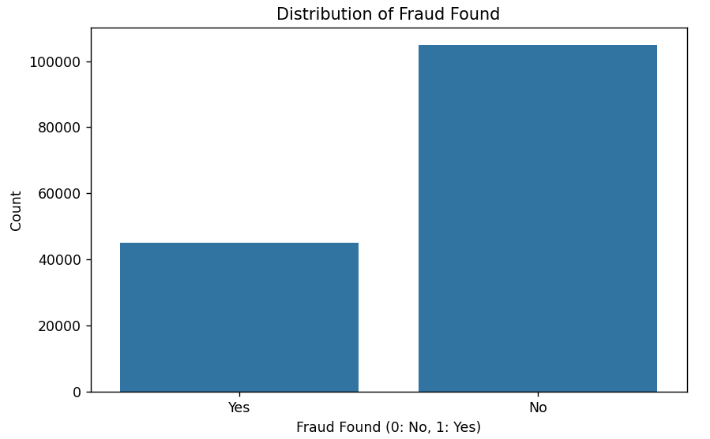

**2. Distribution of numerical features**

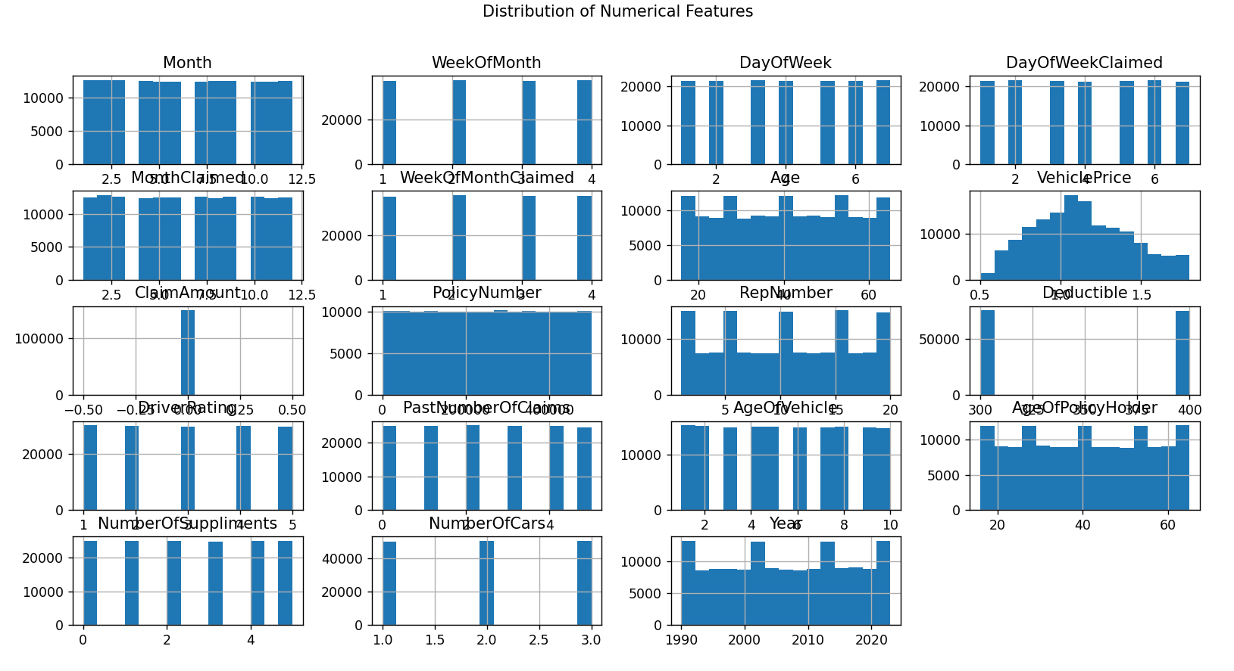

**3. Outlier Detection using box plots**

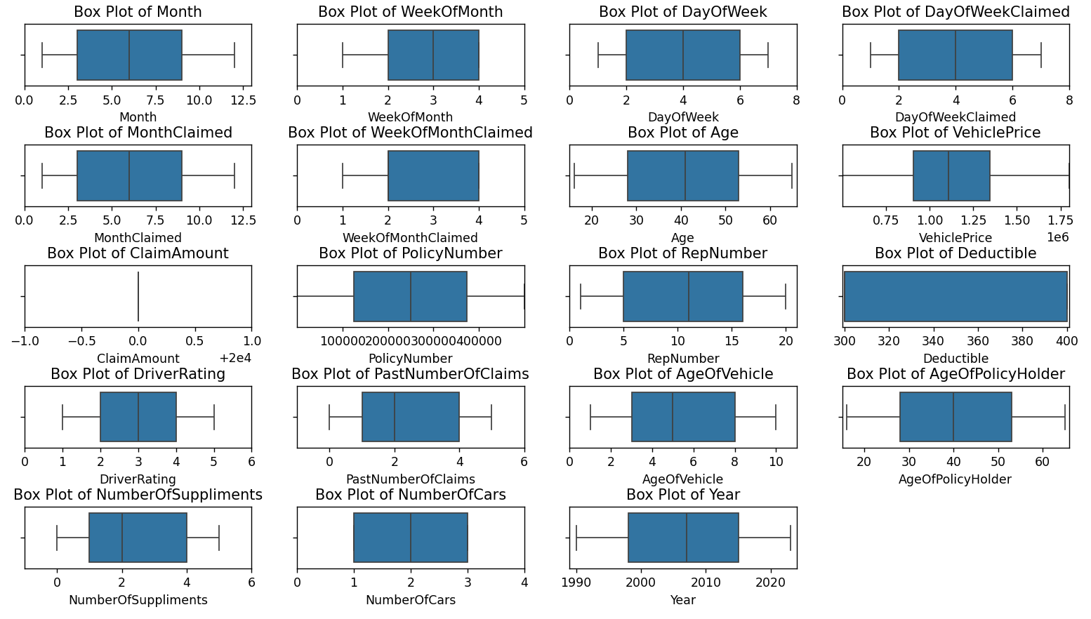

**4.** **Confusion Matrix**

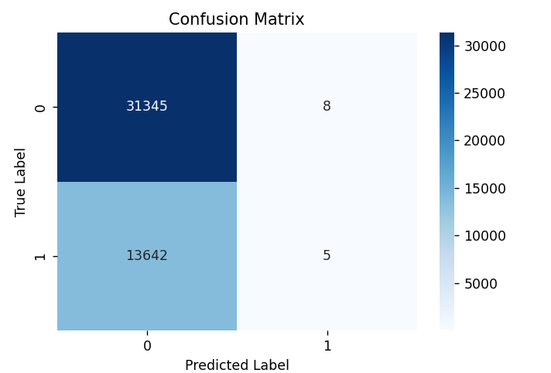

**Gradient Boosted Neural Network :**

**1.Fraud Detection :**

* **Initial model building :**

Gradient Boosted Neural Networks - Accuracy: 0.6966, MSE: 0.3034, MAE: 0.3034, ROC AUC: 0.5035

* **Hyper parameter tuning :**

Final Model with Best Parameters - Accuracy: 0.6905, MSE: 0.3095, MAE: 0.3095, ROC AUC: 0.4967

Best Parameters: {'neurons_1': 64, 'neurons_2': 32, 'epochs': 20, 'batch_size': 16}

Final Model with Best Parameters - Accuracy: 0.6879, MSE: 0.3121, MAE: 0.3121, ROC AUC: 0.5048

Fold 1 - Accuracy: 0.6962

Fold 2 - Accuracy: 0.7003

Fold 3 - Accuracy: 0.6995

Fold 4 - Accuracy: 0.7009

Fold 5 - Accuracy: 0.6988

Average accuracy after k-fold cross-validation: 0.6992

Final Model with Best Parameters - Accuracy: 0.7002, MSE: 0.2998, MAE: 0.2998, ROC AUC: 0.5052

**2.Policy type prediction :**

* **Initial model building :**

Gradient Boosted Neural Networks - Accuracy for Policy Type: 0.3346

MSE: 1.3564, MAE: 0.8957, ROC AUC: 0.5001

* **Hyper parameter tuning :**

Best Parameters: {'neurons_1': 128, 'neurons_2': 64, 'dropout_rate': 0.2, 'epochs': 20, 'batch_size': 64}

Accuracy: 0.3340, MSE: 1.4310, MAE: 0.9210, ROC AUC: 0.5005

**Feed forward neural network :**

**1.Fraud Detection :**

* **Initial model building :**

|  |  |  |  |  |  |
| --- | --- | --- | --- | --- | --- |
| EPOCHS | ACCURACY | MSE | RMSE | MAE | ROC - AUC |
| 50 | 0.6931 | 0.3069 | 0.5540 | 0.3069 | 0.5025 |
| 20 | 0.6958 | 0.3042 | 0.5516 | 0.3042 | 0.5063 |
| 10 | 0.6993 | 0.3007 | 0.5484 | 0.3007 | 0.5001 |

* **Hyper parameter tuning :**

|  |  |  |  |  |  |  |  |  |  |
| --- | --- | --- | --- | --- | --- | --- | --- | --- | --- |
| TRIAL 1 | TRIAL 2 | TRIAL 3 | TRIAL 4 | TRIAL 5 | TRIAL 6 | TRIAL 7 | TRIAL 8 | TRIAL 9 | TRIAL 10 |
| 0.70322 | **0.70323** | **0.70322** | **0.70322** | **0.70322** | **0.70323** | **0.70320** | **0.70320** | **0.70323** | **0.703208** |

Best val_accuracy So Far: 0.7032361030578613

Total elapsed time: 00h 52m 02s

Best Accuracy: 0.7002

MSE: 0.2998

RMSE: 0.5475

MAE: 0.2998

ROC AUC: 0.5037

**2.Policy type prediction :**

* **Initial model building :**

Feedforward Neural Networks - Accuracy for Policy Type: 0.3351

MSE: 1.3589, MAE: 0.8963, ROC AUC: 0.4995

* **Hyper parameter tuning :**

Best Hyperparameters: {'optimizer': 'adam', 'model_neurons_2': 64, 'modelneurons_1': 128, 'model_dropout_rate': 0.2, 'epochs': 30, 'batch_size': 128}

Final Model - Accuracy: 0.3347

MSE: 1.2829

MAE: 0.8711

ROC AUC: 0.4994

**LSTM – Long Short Term Memory :**

**1.Fraud Detection :**

* **Initial model building :**

Before Hypertuning:

MSE: 0.1075

RMSE: 0.3279

AUC-ROC: 0.6056

Accuracy: 0.8733

* **Hyper parameter tuning :**

**Feature Selection :**

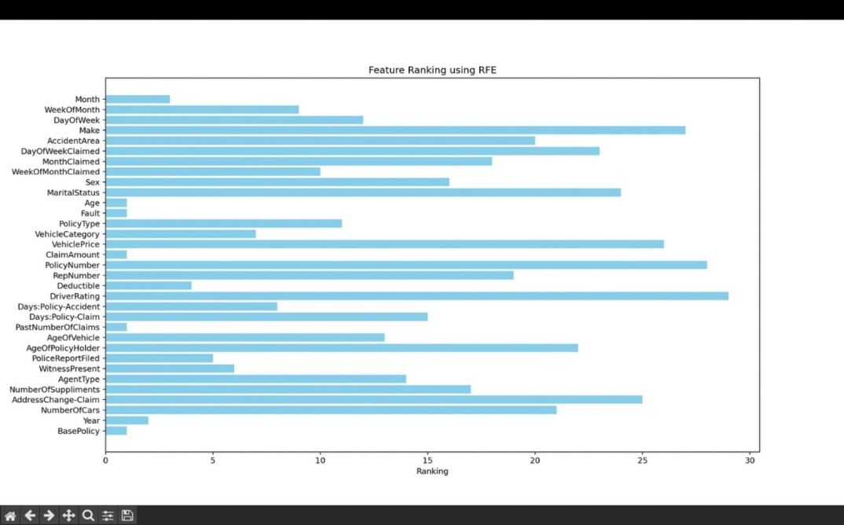

MSE: 0.0796

RMSE: 0.2821

AUC-ROC: 0.6101

Accuracy: 0.9150

**2.Policy type prediction :**

* **Initial model building :**

Accuracy: 0.3345

RMSE: 1.1594826432508596

MSE: 1.3444

AUC-ROC: 0.49916387209903984

* **Hyper parameter tuning :**

Accuracy: 0.3307

RMSE: 1.2427389106324787

MSE: 1.5444

AUC-ROC: 0.5019477077758844

**Autoencoders :**

**1.Fraud Detection :**

* **Initial model building :**

MSE: 0.3215

RMSE: 0.5670

AUC-ROC Score: 0.4963

Accuracy: 0.6785

* **Hyper parameter tuning :**

MSE: 0.3517

RMSE: 0.6214

AUC-ROC Score: 0.3524

Accuracy: 0.6945

**2.Policy type prediction :**

* **Initial model building :**

MSE: 1.6432

RMSE: 1.6743

AUC-ROC Score: 0.5002

Accuracy: 0.3331

* **Hyper parameter tuning :**

MSE: 1.6637

RMSE: 1.6872

AUC-ROC Score: 0.5000

Accuracy: 0.3331

**Prediction :**

**Fraud Detection :**

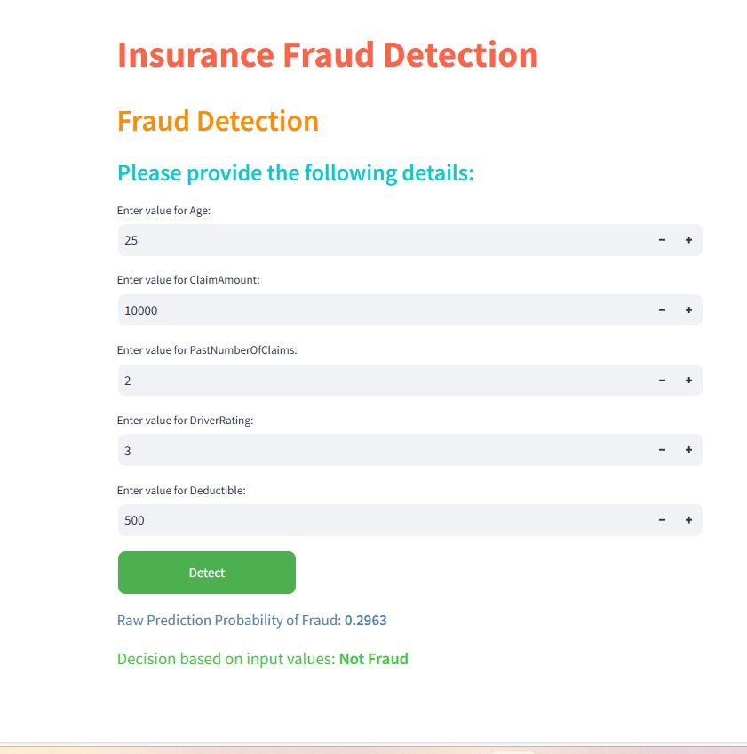

**Insurance Policy Prediction :**

